Case Study: Widgets R Us

James Driscoll

ECPI University

**Situation Summary**

We have this medium size company, Widgets ‘R Us (WRU). They are in the business of creating and making widgets. Currently the company utilizes a functional organizational design. For a while now business has been steady, and the company has been able to keep pace with demand. The problem is that demand for widgets is increasing at a quick pace and WRU is not able to keep up. Some of the problems that are being noticed include: widgets are not becoming available in a timely manner. WRU is not noticing change in widget trends. Lack of communication. Finally, there appears to be a lot of internal fighting among department heads (Pinto, J. K. 2018).

In a nutshell, to quote a line from the movie Cool Hand Luke, “what we have here is a failure to communicate.” (Sloan, 2013). Now, it is not just a failure to communicate, but a failure to communicate effectively. This could be a result of any number of reasons which WRU need to address along with the communication problem.

**Recommendations**

There are two things that WRU can do to get back on track. They involve both conflict resolution and communication. These recommendations need to be accomplished at the same time. In terms of conflict resolution, the following steps need to be followed: 1) Do not ignore there is a problem. The CEO has already noticed the departments heads are fighting. They cannot sit back and hope it resolves itself. 2) Clarify what the issue is. This step is going to involve the CEO getting the department heads together and finding out exactly what the problems are. 3) The CEO needs to facilitate communication between department heads. They all need to air out their grievances and find a resolution no matter how long it takes. This leads to step 4) identify a solution. 5) Finally, the CEO needs to constantly monitor and follow up to make sure the problems have in fact been resolved (Krakoff, n.d.).

**How might the existing functional organizational structure contribute to the problems?**

The organizational structure is not contributing to the problem. Now, an additional recommendation would be to look at possibly rotating personnel between departments. This would give employees a chance to see what the other departments must deal with and how they operate, which would give them a greater understanding of the company.

**Consider either a matrix or a project organization**

* Matrix structure
  + Advantages
    - Collaboration between different departments
    - Combines project and functional management structures
    - Allows interdepartmental communication
    - Employees can develop new skills
    - Team members and managers keep their functional roles
  + Disadvantages
    - Managerial roles may not be clearly defined
    - Team roles may not be clearly defined
    - The decision-making process can be slowed down
    - Too much work can cause overload
    - Measuring employee performance might become difficult (Indeed Editorial Team, 2020)
* Functional Structure
  + Advantages
    - Specialization
    - Operational Speed
    - Operational Clarity
  + Disadvantages
    - Segregation
    - Weakening of Common Bonds
    - Lack of Coordination
    - Territorial Disputes (Gleeson, 2019).

After looking at the advantages and disadvantages of both structures, the recommendation is to go with the Matrix structure. It incorporates one of the recommendations mentioned earlier. Also, it facilitates interdepartmental communication which would mitigate a couple of the disadvantages.

* **Overview of Matrix Structure Diagram**
* (Akiko, 2022)

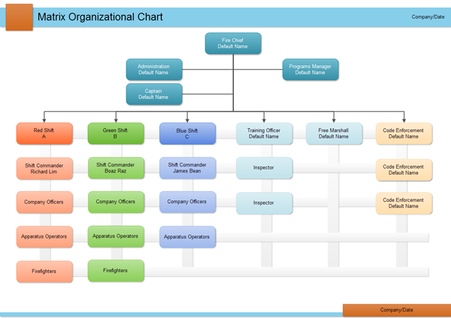

# References

Akiko. (2022, Febuary 23). *Matarix Structure Diagram*. Retrieved from edrawsoft: <https://www.edrawsoft.com/orgchart/matrix-structure-diagram.html>

Gleeson, P. (2019, January 25). *Benefits & Disadvantages of a Functional Organizational Structure*. Retrieved from Chron: <https://smallbusiness.chron.com/benefits-disadvantages-functional-organizational-structure-11944.html>

Indeed Editorial Team. (2020, November 24). *5 Advantages and Disadvantages of the Matrix Orgainzational Structure*. Retrieved from Indeed: <https://www.indeed.com/career-advice/career-development/matrix-organizational-structure>

Krakoff, S. (n.d.). *The Top 5 Conflict Resolution Strategies for the Workplace*. Retrieved from Champlain College Online: <https://online.champlain.edu/blog/top-conflict-resolution-strategies>

Pinto, J. K. (2018). *Project Management: Achieving Competitive Advantage* (5th Edition). Pearson Education (US). <https://ecpi.vitalsource.com/books/9780134730509>

Sloan, R. (2013, December 25). *'Cool Hand Luke' Quote was Right: Filure to communicate is spreading*. Retrieved from UCF Today: <https://www.ucf.edu/news/cool-hand-luke-quote-right-failure-communicate-spreading/#:~:text=Opinions-,'Cool%20Hand%20Luke'%20Quote%20was%20Right%3A,Failure%20to%20Communicate%20is%20Spreading&text=Villainous%20actor%20Strother%20Martin%20uttered,here%20is%>